Enter the name of the game here
Game Design Document
Enter some dialog or other text here
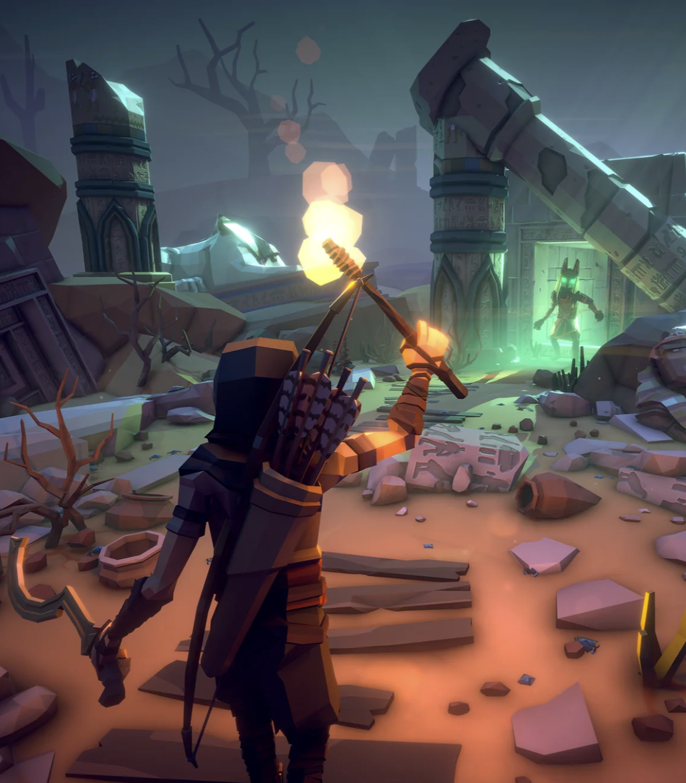

Contents
What is [Name of Game]? 3
Elevator Pitch 3
Concept 3
Design Pillars 3
Audience & Market 4
Story 5
Style & Structure 5
Background Story 5
Storyline 5
Main Scenario 5
Alternative Scenario 6
Characters & Units 6
Character 1 6
Character 2 6
Vehicles & Buildings 6
Vehicle 1 6
Building 1 6
Weapons, Upgrades, & Power-ups 7
Weapon 1 7
Skills & Abilities 7
Skill 1 7
Objects & Items 7
List of Assets 7
Art (visuals & animation) 7
Core Gameplay 8
Objective 8
Core Gameplay Loop 8
Obstacles 8
Gameplay Balance & Pacing 8
Minimum Viable Product (MVP) 9
Controls 9
Character Designs 9
Main Protagonist 9
Main Antagonist 9
Another Character 9
Setting & World 10
Aesthetics: Visual & Sound 10
Narrative 10
Business Model 10
3rd Party Content 11
Game Pitch 11

What is [Name of Game]?
[brief explaination of what the game is in 3-6 sentances and provides 2 example comparative games]
"Here's what we want to make, is that a good idea?"
Add creativity. Custom graphics and fonts that support the concept/feel of the game
"will --> should --> could"

Always start with the broadest and most general, then move into the more specific.

Elevator Pitch
The elevator pitch should be 2-3 sentences that provide a brief explanation of the game, suitable for sharing in an elevator between floors.
[Name of Game] is best described as sadfasdfasdfasdfasdf and similar to [other popular games]. Another sentence that builds curiosity.
Keep it short and sweet, making listeners want to hear more.

Concept
Provide a brief introduction to the storyline. What’s the player going to learn in the first 5 minutes of the game loading and getting started? What’s that huge, overarching goal?
Provide a brief discussion on how gameplay feels or is experienced.
Keep it fun.
Provide a list of other games, movies, TV shows, books, etc. which are influencing the design of this game. Identify the primary influencers and, if applicable, how they are influencing the design.

Influences & References
Game Influences:
[insert which games influenced this one and how/why]
Non-Game Influences:
[Insert which other media (movies, books, music, etc) influenced this game and how/why]

Details, Tags/Categories, Platforms, etc.
Quick Details
Price:
Platforms:
Primary Genre:
Store Genres:
Content Descriptors:
Store Platforms: Itch.io (prototypes, community building), Steam, Epic Games Store, ???
Tags:
[Insert tags to be used in stores or social media here]
Accessibility:
[insert accessibility features to be included (if any)]
Adjustable Text Size, Subtitle Options, Color Alternatives, Camera Comfort, Stereo Sound, Narrated Game Menus, Playable without Timed Input, Keyboard Only Option, Mouse Only Option, Adjustable Difficulty, Save Anytime
Languages Supported:
Primary: English
Localization via https://www.deepl.com
Primary AI Localization: French, Italian, German, Spanish – Spain, Japanese, Korean, Polish
Secondary AI Localization: Chinese, Portuguese – Brazil
Video Features:
Widescreen resolution, 4K Ultra HD, Windowsed, Borderless full screen windowed, Anisotropic Filtering (AF), Anti-Aliasing (AA), High-fidelity upscaling, Frame generation (DLSS), Vertical sync (VSync), 60 FPS, High dynamic range display (HDRP), Ray tracing (RT)
Input Features:
Remapping, Mouse sensitivity, Mouse acceleration, Mouse input in menus, Keyboard & mouse prompts, Mouse Y-axis inversion
Controller support, full controller support, controller remapping, controller sensitivity, controller Y-axis inversion
Audio Features:
Separate volume controls (Master, Music, Voice, Sound Effects), Surround sound, Subtitles, Closed captions?, Mute on focus lost?, Royalty free audio, Streaming friendly

Design Pillars
[We use design pillars to focus our design choices as we move through the project. For the purpose
of this project, we want our design pillars to identify the types of fun or enjoyment which are key
to the user experience] [What things are holding this game up? What is essential to success?
How does this focus the player’s experience?]

Use the framework "The 14 Forms of Fun" https://www.gamedeveloper.com/design/fourteen-forms-of-fun
These fourteen forms of fun are, in no particular order:
- Beauty
- Immersion
- Intellectual Problem Solving
- Competition
- Social Interaction
- Comedy
- Thrill of Danger
- Physical Activity
- Love
- Creation
- Power
- Discovery
- Advancement and Completion
- Application of an Ability

Select 2-4 as pillars. For each one, describe why it was selected and how it will be leveraged to help guide decision-making. Reference these pillars in other parts of the GDD and in other documents. Include how one may influence another.

Bartle’s Player Taxonomy
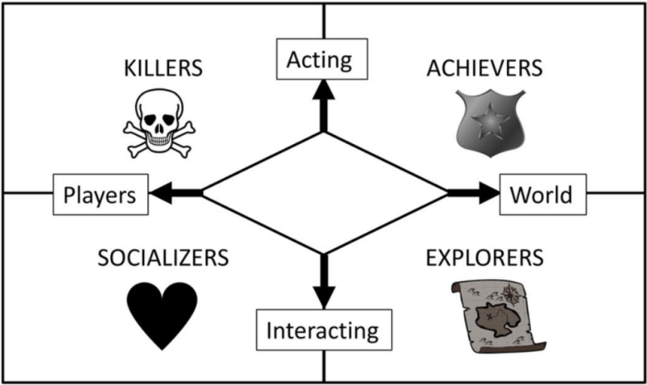

[Describe how your game is engaging each player type, even if minimal engagement. If not targeting one, explain why]

Gamer Motivation Model
Quantic Foundry (https://quanticfoundry.com/) has developed the Gamer Motivation Model after analyzing data from over 1.75 million gamers. Reviewing the model, describe how the game meets the motivation expectations of the target audience. https://quanticfoundry.com/wp-content/uploads/2019/04/Gamer-Motivation-Model-Reference.pdf
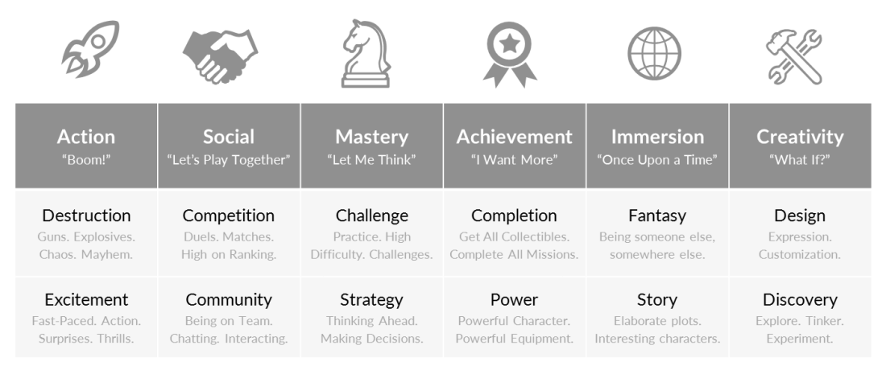
[Explain how your game is meeting each motivation]

Audience & Market
This can be as simple as identifying your target age group or other demographics.
It's about who you are making the game for. Who's going to buy it? How are you going to reach them? What will your materials look like? Does your genre match with the platform?
The game is designed to be played online with other players via Steam. A single-player "casual" mode without the competitive experience will also be available.
The game will contain some irreverent humour about religion, as well as some brutal slapstick violence. It will be aimed at the teen-adult audience.

NEVER DESIGN A GAME FOR EVERYONE! It has to be for someone. If you can't identify who it is for, start by identifying who it is not for.

Minimum Viable Product (MVP)

Story
Tell us about the story of the game and the main characters

Style & Structure
What is the style of the story? Is it horror, science-fiction, western, etc? What is the period of the story? Is it futuristic, prehistoric, etc? Does the style or ambiance vary during the game? Give us as much detail as you can, and justify your choices. Why is that the best style or ambiance for your game? What is the structure of the storyline? Is it divided into chapters or levels? Is it linear? If not, how can the player influence the story? Are there alternative endings?

Background Story
Use this section to detail the story that took place before the beginning of the game. For example, what was the hero’s occupation? How did he become a hero? What events led to the objectives the player has to accomplish?

Storyline
Detail the story as it unfolds during gameplay; include a storyboard if applicable. This is where you detail the succession of events. What are the central events? How does the story culminate? If your game has dialog or narration, detail the most important portions here. This section might look somewhat like a movie script.

Main Scenario
Detail here how the player interacts with the game, through the hero, from beginning to end. This is where you detail the succession of challenges. This is not a movie script, unless your game is completely linear; and even then, remember a video game is interactive. Try to detail the options available to the player instead of stating what you think he is going to do. Describe how he optimally goes through the game; for example, you would say “This is the path the player would take in order to complete the game” instead of “The player takes this path”. How long does it take to go through the game with this scenario? Detail his options whenever they change, how, why, and how it affects the game. This section should be very similar to a basic walkthrough written in third person (the player).

Alternative Scenario
Detail here every alternative option to the main scenario, and any additional options that appear as a result of an alternative choice by the player. For each option, detail when it appears to the player, how and why he would choose that option, and how it affects the game and the length of gameplay. This section should be very similar to a 100% completion walkthrough written in third persion (the player). If your game has collectables, Easter eggs, or unlockables that can be found during gameplay, indicate each at their respective location. Try to make them easy to locate in your text, since a developer might read this section just to find them.

Characters & Units
Detail all of the game’s key characters here. For each of them, detail their background and personality, what their role in the game is, and any other useful information. Start with the character which the player plays (the hero). Why would (s)he want to impersonate that character? What is compelling about their story?

Character 1
Describe character 1 here.

Character 2
Describe character 2 here.

Vehicles & Buildings
Detail the story of the game’s key vehicles and buildings, if applicable. For each of them, detail their background and what their role in the game is, as well as any other useful information.

Vehicle 1
Describe vehicle 1 here

Building 1
Describe building 1 here

Weapons, Upgrades, & Power-ups
Detail the story of the game’s key weapons, upgrades, and power-ups, if applicable. For each of them, detail their background and what their role in the game is, as well as any other useful information.

Weapon 1
Describe weapon 1 here.

Skills & Abilities
Detail the story of the game’s key skills and abilities, if applicable. For each of them, detail their background and what their role in the game is, as well as any other useful information.

Skill 1
Describe skill 1 here

Objects & Items
Detail the story of the game’s key objects and items, if applicable. For each of them, detail their background and what their role in the game is, as well as any other useful information.

List of Assets
List the entire story resources that need to be created, obtained, or utilized. This includes dialogues, narration, lore, and every other story asset your game will require. Refer each element to its source in the documentation and to its filename. Make sure to use a file naming convention, it will make the job much easier later on.

Art (visuals & animation)
Covers every visual aspect of the game and how each element will look and feel.

Style
Describe the general style of the graphics here. Is it cell-shaded, manga, or realistic? What is the mood, the colors, and the characteristics? If different styles of graphics are used throughout the game, specify them. Detail why you chose the specific graphics and how they add to the game. If you can refer to the graphics of another game as an example, do not hesitate to do so. Whenever possible, include sketches.

World
Detail the appearance of the game’s world here. Include all locations that can be visited by the player. Include sketches if possible. Describe backgrounds, textures, tiles, and other terrain objects.

Location 1
Describe the appearance of location 1 here.

Physics
How do the physical reactions of objects in the game look like? Are they realistic, cartoony, funny, or exaggerated? Are there special effects? If so, describe them.

Characters & Units
Detail the appearance of the game’s key characters here. Start with the character(s) the player plays. Describe every different motion type, and say to which character it applies. Include illustrations if possible, but you have to at least sketch the general idea of each one, no matter how insightful your drawings look.

Character 1
Describe the appearance of character 1 here.

Vehicles & Buildings

Core Gameplay
What does the player do and how does the player do it?
Core systems/mechanics (actions/activities players or NPCs might engage in)
Include MVP (minimum viable product) and that others may be added at later date.

Include level up or tech tree system and why it is in the game from gameplay and how it fits overall

Justify what you are doing. The reasons why.

Objective

Core Gameplay Loop

Obstacles

Gameplay Balance & Pacing
Outline the broad approach. No big excel sheet at this stage (separate document).
How long does it take to play a stage?
What factors might impact the length of play? How does skill impact the experience or length of play?

Are the level gates to control progression? Sections of the map destroyed? Sections of the map open up?
Player reaches a certain level or growth or collecting and some event happens to knock them down?

Controls
What are the controls for the player to move? How do NPCs move? (general, not detailed)
List out the actual mechanics of the controls

Character Designs
Describe the art style and the significance of it. Include screenshots.
List out an distinct features or colors (different classes of character or factions)
Include if the art influences the gameplay in some way
Categories of NPCs and their role/player interactions

Main Protagonist

Main Antagonist

Another Character

Setting & World
Describe in 1-2 sentances. Include a scoped down version for prototype and vertical slice versions.
What shortcuts will be used for prototype and how will they change for production?
(do not spend weeks/months building out a procedural generation rule set just to find out the game isn't viable)
(use existing content to rapid prototype, prove the concept, then build it good)

Aesthetics: Visual & Sound
"The visual style and iconography of the game will be developed as the project progresses."
Include sources of inspiration. Example color palettes. Pull color palettes from other movies/games.
How's the lighting? The mood?
Art style guide with mood boards and references should be separate document.

Business Model
Free, freemium, subscription, one-time purchase?
In game purchases? Loot boxes? Currency? Upgrades?
Release plan
1. Initial limited-features free demo release to gain initial interest
2. Kickstarter campaign to raise funds to develop all features and content
3. Full premium release in the $XX price category
Does anything from 1 carry over to 3?

3rd Party Content
List out links to all 3rd party content that will be used. This will aid others in quickly understanding where systems or assets are coming from and locating related documentation and support channels.
[ INSERT bulleted list ]

Game Pitch
Include your official game pitch here. The game pitch is how you would explain to game to a potential investor or marketing agent. You are selling the game to someone. This should take 5 – 10 minutes to explain. Shorter is better. Do not explain systems or mechanics that are common to other similar games. Here is a basic structure to guide you:
Who are you and why do you have the ability to build this game?
Give your elevator pitch
Give your basic starting storyline
What other games, movies, TV, books are influencing this game?
What platform will you be using?
What limitations or risks exist?
- Lack of resources?
- Lack of assets?
- Lack of time?
How will you mitigate these limitations or risks?
- Purchase systems or assets from marketplaces?
- Contract for services?
- Leverage interns from local universities?
What are the financial considerations for the project? Both what has already been covered and what future expenses could be anticipated.
- 3rd party systems or assets
- Licensing fees for intellectual property
- Product launch expenses
- Advertising and marketing costs
- Labor expenses (staff/consultants)
How will these financial considerations be addressed?
Will you get player input before release (prototypes or vertical slices)?
What is the basic structure of the game?
- How many levels will there be?
- How long will it take to play a level?
- How long will it take to play the entire game?
- What will differentiate one level from another?
- Are there any key systems the player will encounter within the levels?
What is the general gameplay experience for the player?
- Fast-paced slaughter?
- Slow world exploration with extensive narrative?
How does this game set itself apart from other games? What is the unique selling point?
Wrap-up

